Amendments of the IRC Rule in 2020
- Amendments with NO impact to TCC
- IRC 8.2 and 8.2.2: has been updated to clarify that a certificate must be valid for the country in which the boat is racing.
A boat which is racing in a country from the North Hemisphere, may hold a second valid IRC certificate when racing in a country from the South Hemisphere.
Comment: The preamble of the IRC Rule states that IRC Rule 2020 applies in the countries of the North Hemisphere from the 1 January to the 31 December 2020. IRC Rule 2020 applies in the countries of the South Hemisphere from the 1 June 2020 to the 31 May 2021.
8.2 A boat shall hold a current IRC certificate valid in the country in which it is racing. A boat shall not hold more than one valid IRC rating certificate at any time except as permitted by Rules 8.2.1 and 8.2.2.

8.2.2 Issue of any new rating certificate automatically invalidates the old one except when a new certificate is issued to enable a boat to race in another country with a different certificate year end.
- IRC 21.4, 21.1.5.b) and 21.2.2: IRC Rule 21.4 is deleted and reference to sailcoth containing exotic materials has been moved to Rule 21.2.2 Rig Factor. Currently, IRC does not define any sailcloth material as an exotic material.
21.2.2 RF may be increased for: fractional, racing and lightweight rigs, high aspect ratio and efficient plan forms, wing and double luff sails, specialized sail stiffening, exotic sailcloth materials, large headboards/cranes, permanently bent or highly controllable spars, hi-tech rigging, exotic rig materials, advanced winch and deck gear arrangements, flush/efficient deck design, and any other feature which increases sailing efficiency that is not already rated through the rated dimensions.

- IRC 22.1.1: has been updated to include the Inshore Racing Category (Offshore Special Regulations).
22.1.1 Detachable items (such as but not limited to bunk cushions) permitted by Rule 17 to be aboard for measurement shall be carried in their normal positions while racing. For races requiring compliance with OSR Category 4 or Inshore Racing Category only (or local equivalent), a Notice of Race may state that boats rated with bunk cushions on board may remove the bunk cushions. No compensating weight need be carried.

Comment: if a Notice of Race does NOT state that boats rated with bunk cushions on board may remove them, the bunk cushions shall stay on board if the owner declared to keep them when declaring the data to IRC or when the boat has been IRC weighed with the bunk cushions.
- Appendix 2 – IRC MEASUREMENT DIAGRAMS : This appendix was mentioned in the text of the IRC Rule with no formalized content. This appendix gathers the diagrams of keel types, measurements of overhangs, sails measurements and rig measurements and details. This appendix will be updated over time.
- Amendments WITH a potential impact to TCC
- 8.2.1: has been updated to allow the number of spinnakers to be changed for a short-handed certificate.
8.2.1 A boat may additionally hold a separate short-handed certificate. This short-handed certificate shall be valid only for racing in classes, or divisions of classes, for no more than 2 crew, included in a Notice of Race. When specified in a Notice of Race, boats holding short-handed certificates, and racing in a short-handed class or division, may also be scored in the overall results of the race. The short-handed certificate will be clearly identified and shall only vary from the primary certificate in respect of, mainsail widths, headsail dimensions, single furling headsail allowance, the use of stored power, SPA, STL, spinnaker pole/bowsprit, number of spinnakers, moveable ballast and variable ballast. A boat holding a shorthanded certificate shall use that certificate for races for no more than 2 crew.
Additional comments about the Short-Handed certificate
A short-handed certificate MAY be usefull only when a boat has a « mixed » races program during a year (alternatively races with a full crew and others with a single or 2 crew).
If a boat with a mixed races programs does not change one or more of the elements listed in IRC Rule 8.2.1 when racing in a short-handed race, there is no need of a short-handed certificate and the prior “standard” certificate stays valid for short-handed races. If a boat with a mixed races programs changes one or more of the elements listed in IRC Rule 8.2.1, the owner may ask for the amendment of his current IRC “standard” certificate OR ask for a short-handed certificate.
The Crew Number/Crew Weight stated on an IRC Certificate is the result of a calculation by the IRC software. It has no impact on TCC. This Crew Number/Crew Weight can NOT be amended following the declaration of an owner.
A short-handed certificate can NOT be edited without an existing, valid and prior « standard » IRC certificate. When a boat holds an IRC « standard » certificate and a short-handed certificate, and the owner wants to participate to a short-handed race, the short-handed certificate SHALL be used (the owner does not have the option to choose between the 2 existing certificates.
- 21.3.5 and IRC Definitions of a Whisker Pole and STL:
The use of poles set to leeward to act as struts for the sheeting of headsails is becoming more common, both with boats rated for headsail only and boats rated with spinnakers who can use them provided a spinnaker is not set.
World Sailing RRS 50.3.c) rules the use a pole for the sheeting of headsails:
RRS 50.3 (c) A headsail may be sheeted or attached at its clew to a spinnaker pole or whisker pole, provided that a spinnaker is not set.
World Sailing ERS F. 1.4.(d)(ii) provides a definition of a whisker pole:
ERS F.1.4.(d)(ii) WHISKER POLE
A spar attached to the mast spar and a headsail clew.
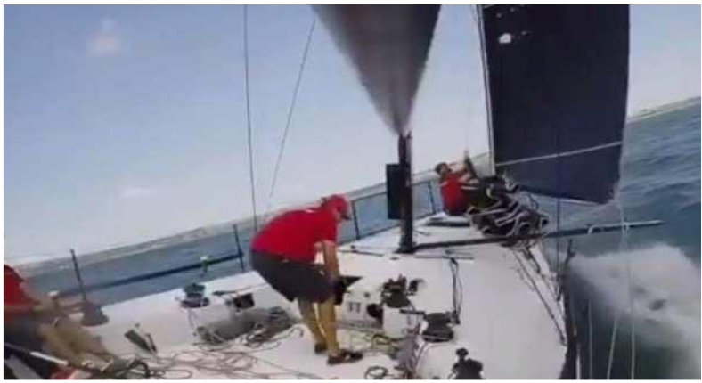
In the above picture, the headsail sheet (but not the clew of the sail) is attached to the pole.

World Sailing states that such a configuration is permitted by RRS 50.3.(c). According to the interpretation of World Sailing, RRS 50.3 (c) does not specify or restrict how the headsail is to be sheeted to the pole.
Reference: « World Sailing Racing Rules – Question and Answer Service, Q&A 2019.017: https://www.sailing.org/tools/documents/QA2019.017L003-[25287].pdf )
Based on the lack of clarity provided by the RRS and ERS, IRC amends her rule and Definition to clarify which are the permitted configurations with an impact to TCC.
21.3.5 Boats will be rated according to whether they use a spinnaker pole, whisker pole and/or a bowsprit according to the following configurations:
(a) No spinnaker pole (spinnaker tacked on deck) or a centre line bowsprit only.
(b) An articulating bowsprit only.
(c) Spinnaker pole(s) and/or whisker pole(s) either with or without a bowsprit.

Definition of STL
STL The greatest horizontal distance from the forward face of the mast spar, ignoring any fittings and tracks, measured on or near the centreline of the boat, to any of the following:
- the extremity of the spinnaker pole, whisker pole or bowsprit, ignoring any outer limit marks;
- the spinnaker tack point on deck projected vertically as necessary;
- if a headsail may be tacked forward of the forestay, the headsail tack point on deck projected vertically as necessary or to the extremity of the bowsprit.

Definition of a Whisker Pole
Whisker Pole A spar attached to the mast spar to set a headsail. ERS F.1.4(d)(ii) does not apply.
In this way, IRC makes clear the permitted configurations, with an impact to TCC. The headsail clew or the headsail sheet may be attached through the end of a whisker pole or a ferrule along the length of this pole.
- IRC 22.3 Movable Ballast and Variable Ballast
IRC Rules 22.3.1 to 22.3.7 are amended or created to provide an IRC new effective framework to rate the movable ballast (canting keel) and the variable ballast (transferable liquid ballast).

This framework distinguishes 3 cases :
- A boat fitted with variable ballast ONLY
- A boat fitted with movable ballast ONLY
- A boat fitted with BOTH variable ballast and movable ballast.
It should be noted that the impact of variable ballast to TCC is significantly reviewed in 2020.
22.3 Moveable Ballast and Variable Ballast
22.3.1 A boat may use moveable ballast and/or variable ballast and any such system shall be permanently installed and shall be declared to the Rating Authority. RRS 51, Moving Ballast, and RRS 52, Manual Power, are modified in respect of moveable ballast and/or variable ballast systems to the extent required by this class Rule.
22.3.2 List angle is measured in the boat weight condition (see Rule 17) with any additional variable ballast. There is no limit to the list angle with ballast tanks fully filled on one side of the boat and/or with moveable ballast moved fully to one side.
22.3.3 For boats with variable ballast only, the maximum list angle and the maximum volume of water, including plumbing that can be carried on each side of the boat shall be declared.
22.3.4 For boats with moveable ballast only, the maximum list angle shall be declared.
22.3.5 For boats with variable ballast AND moveable ballast, the maximum volume of water, including plumbing, that the variable ballast may carry on each side of the boat and the maximum list angle specific to the moveable ballast, with empty variable ballast tanks, shall be declared.
22.3.6 A physical, mechanical limit shall be fitted to all moveable ballast system to prevent it being moved further than the position for the declared list angle. Such a system shall not rely on sensors or measurement to prevent the declared list angle being exceeded unintentionally.
22.3.7 For boats with variable ballast systems that are declared as not used, the system shall be disabled.

- IRC Definition of the Bulb Weight
There appears to be a trend in some classes to design an overly large keel fin foot to perhaps exploit the IRC bulb weight measurement and definition. The new definition of the bulb weight includes the weight of any fin foot that is inside the bulb.
Bulb Weight The weight of the Bulb and any part of the Keel below the upper surface of the bulb (including connection plates, under-fin spacers and infills)
- Amendments of the IRC software with no amendment of the wording of the rule.
The IRC 2020 software reconsiders how to rate the flat keels (Types 4, 5 and 6), by implementing a gradual taxation in respect of the keel aspect ratio. Hence, there will be no more « big gap » between those 3 types of keels, but a proportionate taxation reflecting the real efficiency of each keel.
The IRC Technical Committee will proceed to a global research including all the types of keels in 2020.
In practice, and for each keel, the IRC Rating Offices (UNCL Centre de Calcul and Seahorse Rating Ltd), will use the upper keel chord, lower Keel chord and keel span when rating a boat. The Rating Offices know already those data for a huge number of boats.

END

